RECAP GR 11

Electromagnetic induction – a phenomenon whereby a magnetic field moves closer to a conductor, or when a conductor moves through a magnetic field, an altered magnetic field occurs that induces an emf, therefore letting current flow through the conductor

To induce current, magnet must be held still, and the conductor must be moved OR the conductor must be held still, and the magnet moved.

An altered magnetic field induces an emf in the conductor and the emf causes an induced current.

Magnetic flux



Φ is the magnetic flux

B is the magnetic field

A – area

θ – angle between a perpendicular vector to the area and the magnetic field

faraday’s law

the magnitude of the emf induced in a coil is directly proportional to the rate of change of the magnetic flux

faraday’s equation

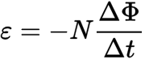

E – induced voltage

N -number of loops

Φ is the magnetic flux

t- time

Ways to increase induced emf and current

* Move the conductor faster
* Use strong magnets and give stronger magnetic fields
* Use a longer conductor that can move through the magnetic field, i.e by coiling the conductor

ELECTRODYNAMICS GRADE 12

Generators:

Energy conversion : - mechanical energy to electrical energy

Principle used by generators: faraday’s law

Components of a generator:

* Armature: Allows emf and current to be induced through it, as it rotates in the magnetic field.
* Wire which is wrapped around the armature
* Magnets: provides magnetic field that passes through the armature
* Slip rings: Allows current to change direction every half-rotation of armature.

Allows continuous contact with brushes so that current can be transmitted to terminals without breaking the circuit.

* Carbon- brushes: maintains electrical contact with the slip rings.

conducts or takes current out of the coil.

RIGHT HAND RULE

* Thumb points in the direction of the force
* Index finger points in the direction of the magnetic field.Magnetic field is always directed from North Pole to South Pole.
* Middle finger points in the direction of the current.
* **The rms potential difference is the AC potential difference which dissipates/produces**

**the same amount of energy as an equivalent DC potential difference.**

* **The rms current is the alternating current which dissipates/produces the same amount**

**of energy as an equivalent direct current (DC).**

AC GENERATOR VS DC GENERATOR

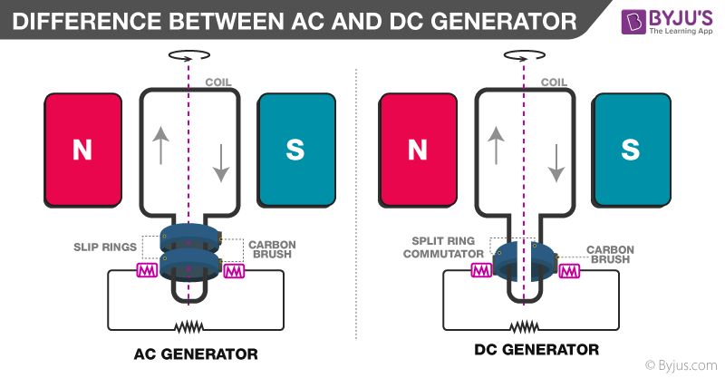

MOTORS

Use the left hand rule with the thumb, index and middle fingers serving the same purpose as in generators.

